The inspection was carried out by the undersigned officials on the basis of applications in Form MD-07 for additional products, furnished by {manufacturerName}, having manufacturing site located at {manufacturerAddress} its application No. {applicationNumber}, dated {applicationDate} The manufacturing site was inspected as per the instruction received vide letter F. No. {videNumber}, dated {videDate}.

Purpose of inspection:

Inspected site and Date:
{manufacturerName}, {manufacturerAddress}, Date: {inspectionDate}

Name of the Inspection team members:

Following technical personnel were present throughout the inspection:
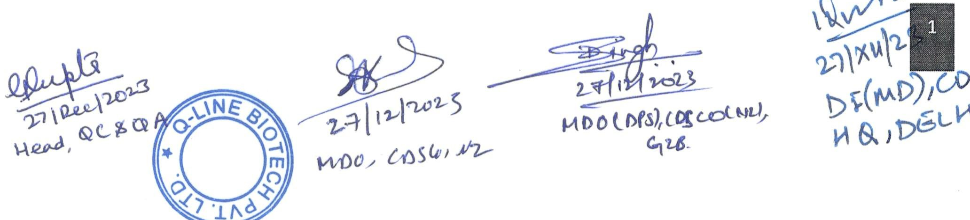

General Observation:
Facing towards {manufacturerName}, {manufacturerAddress}
Total area of the plot | =
Total Covered Area | =
RM Stores | =
Packing Stores Basement | =
Production | =
QC Lab | =
FG store Area | =
QA Dept. | =
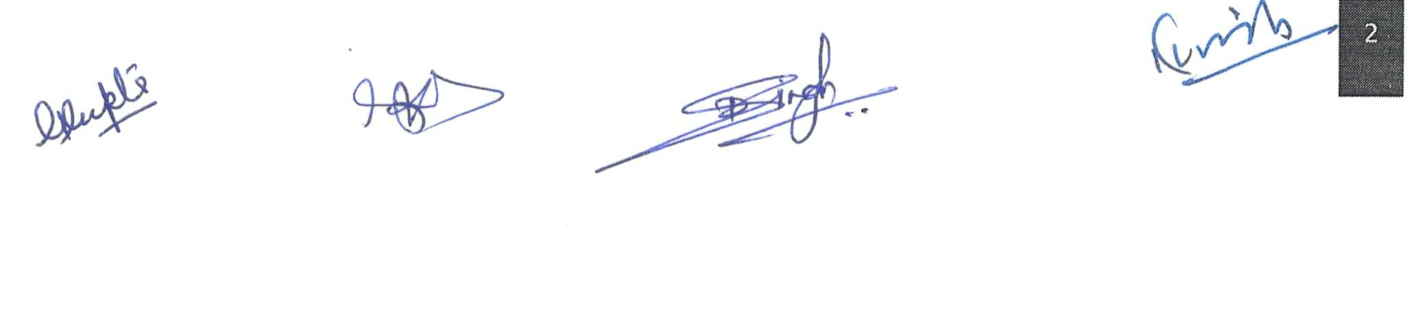

LIST OF DOCUMENTS/APPROVALS

PREMISES, BUILDING AND LAYOUT
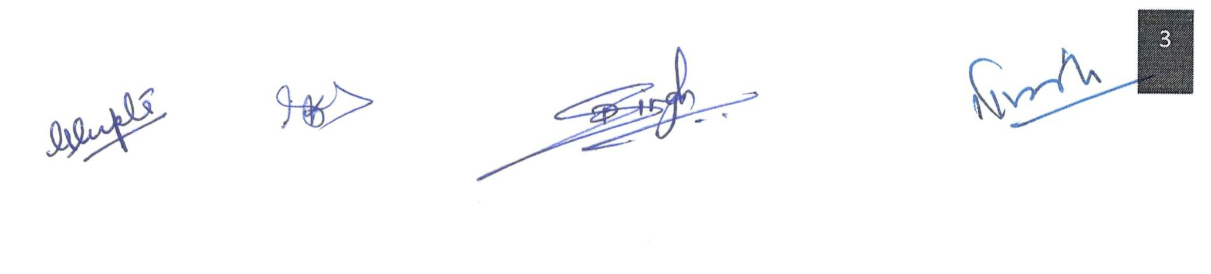

S. No. | Floor No. | Plot No. H-2
1.
2.
3.

Personnel
Adequate technical personnel with requisite qualification has been employed and were present on day of inspection for discussion and demonstration of manufacturing and testing activities. The list of technical personnel along with their qualification and experience in testing of different Medical Devices is mentioned below:
Key Person | Qualification | Experience | Responsibilities
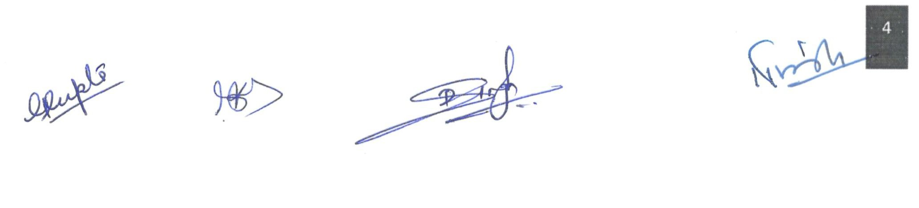

ORGANOGRAM:

VENTILATION SYSTEM:

Water and ETP system:

Equipments:

The testing equipments are regularly calibrated under their scheduled programs and intervals and record maintained.
S. No. | Machinery / Equipment | Qty
1
2
3
4
5
6
7
8
9
10
11
12
13
14
15
16
Sanitation:
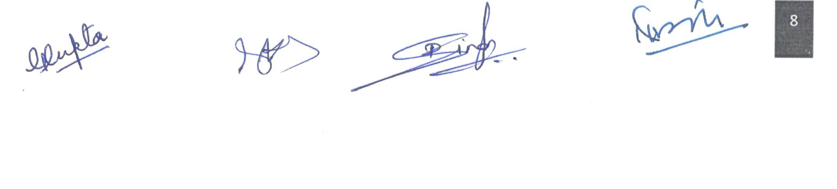

RM/PM (PRODUCTION):

PROCESS VALIDATION:

Quality Assurance/Control:

Storage:

DOCUMENTATION:
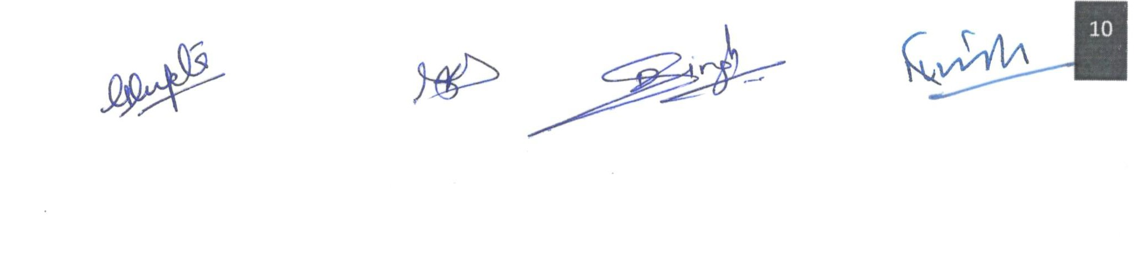

MEDICAL DEVICE COMPLAINTS AND FIELD SAFETY CORRECTIVE ACTION

INTERNAL AUDIT:

CONTRACT ACTIVITES:
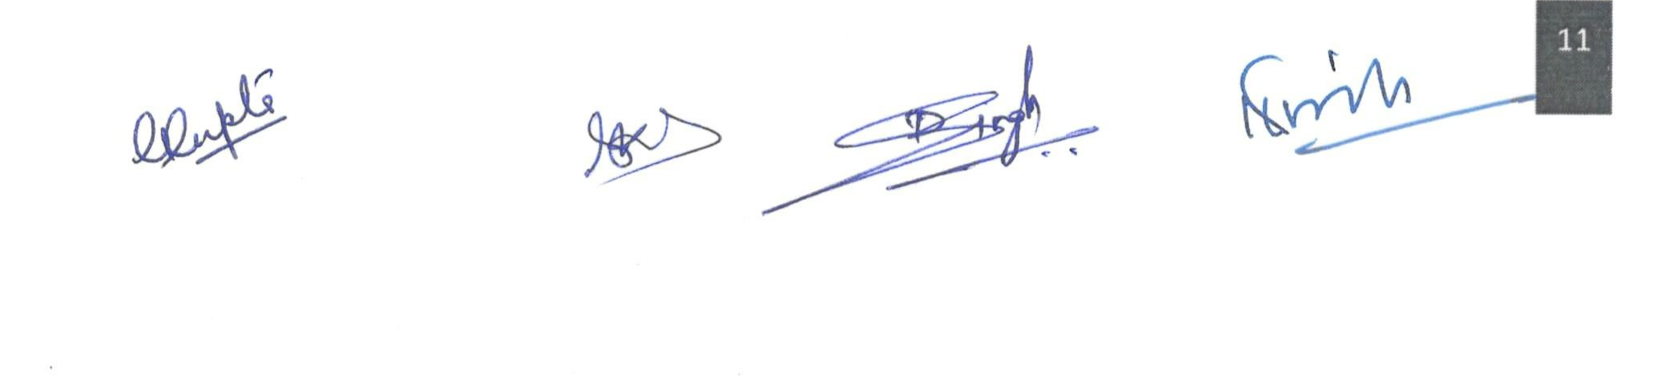

CONTROL OF DOCUMENTS AND RECORDS

TRAINING:

PRODUCT REALIZATION: {productName}
PRINCIPLE :
{intendedUse}
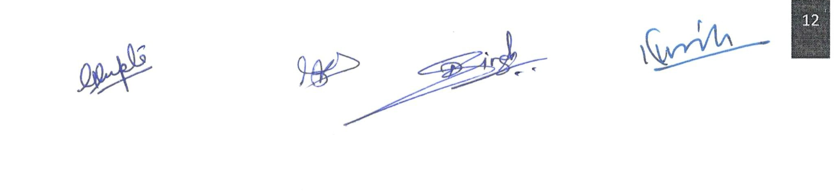

Class: {productClass}

Novel Feature:
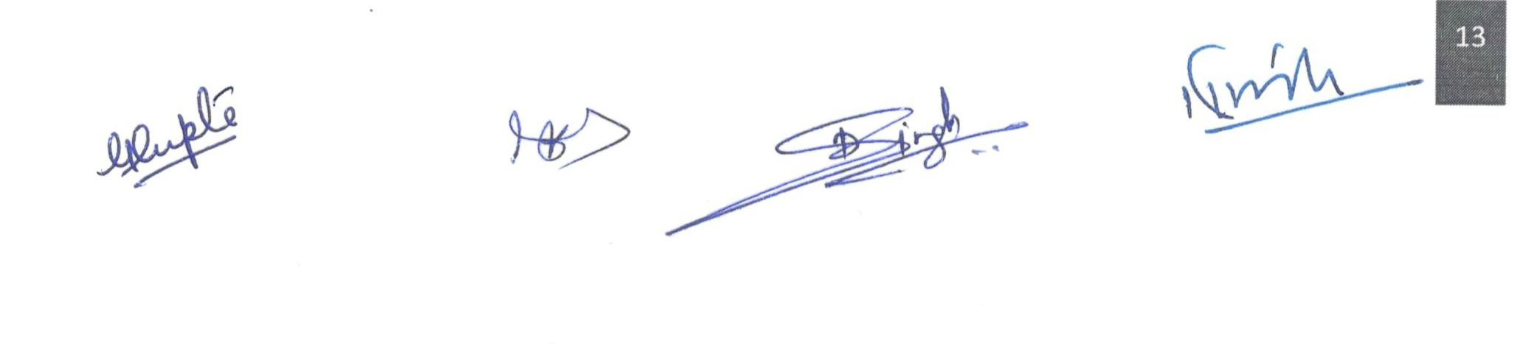
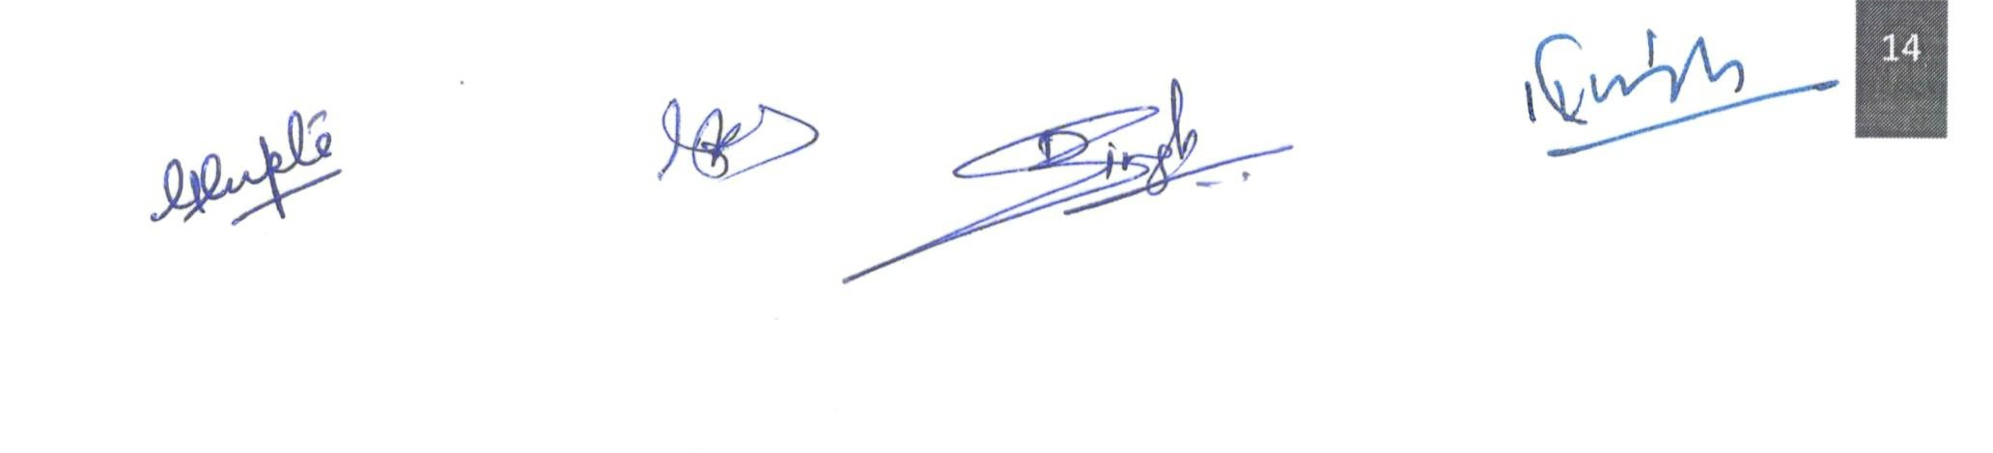

Claimed Shelf life:

{shelfLife}
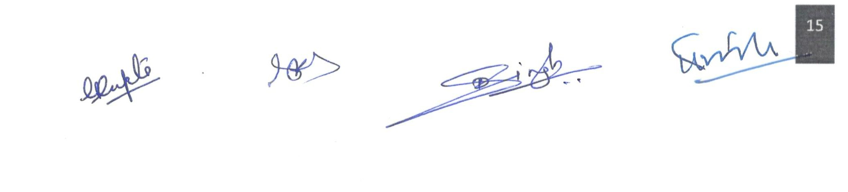

OBSERVATIONS:

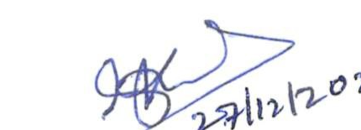  (Pramod Kumar)  Medical Device Officer,  CDSCO, NZ, Ghaziabad | 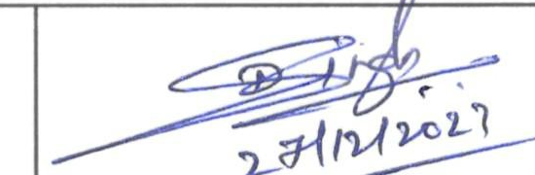  (Devendra Pratap Singh)  Medical Device Officer,  CDSCO, NZ, Ghaziabad | 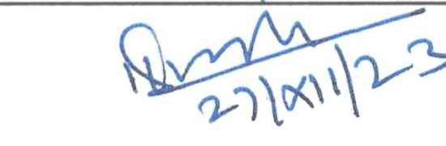  (Jal Singh)  Drugs Inspector (Medical  Device), CDSCO, HQ, Delhi.
